2022-2023 AUXILIARY SHIRT ORDER FORM
Diana Ward Department Long Sleeve shirt will be burgundy 100% cotton blend with a White lettering. Please indicate the size(s) of the shirt(s) you wish to purchase.

Deadline to order a shirt and have it to pick up at State Convention is April 1, 2022.
Orders will be accepted after this but will not be available by Convention.

Same shirt for both the Men and Women’s- Please see samples for sizing
S______ M______ L______ XL______ 2X______ 3X______ 4X______

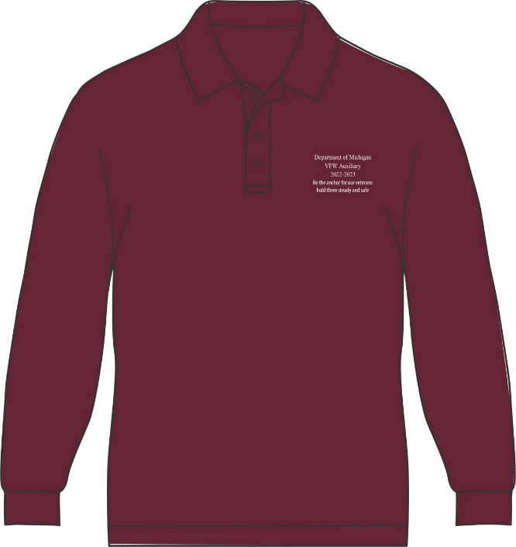
Department of Michigan
VFW Auxiliary
2022-2023
Be the Anchor for our Veterans
hold them Steady and Safe

They run True to Size
Shirts are $35.00. Make checks payable to: Diana Ward
Mail order form and check to:
Diana Ward
11463 Skyline Dr
Fenton, MI 48430

Enclosed is check/cash in the amount of $____________ for _______ shirt(s).

Name____________________________________________________

Phone Number_____________________________________________

